**The Kenya Reptile Atlas**

A free, downloadable atlas of Kenya’s reptiles. This is a free source of regularly updated information on Kenya’s Reptiles. Authors: Stephen Spawls, Beryl Bwong, Patrick Malonza, Vincent Muchai, Victor Wasonga

Obtainable under ‘downloads’ at Kenyareptileatlas.com

This project is funded by the Rufford Foundation under the auspices of the National Museums of Kenya; Department of Herpetology.



The Kenya Reptile Atlas offers you:

Pictures of Kenya’s reptiles

Distribution maps by quarter-degree-square

A description of the species

Click on any of the titles listed under the downloads tab to download for free. The various families will be added as the accounts are completed.

If you have any observations of Kenya’s reptiles, any distribution records, or any other data, or any digital pictures, we would like to receive them! Send them to [Kenyareptileatlas@gmail.com](mailto:Kenyareptileatlas@gmail.com)

And if you live or travel in Kenya, and find any dead reptiles, please preserve them and take them to the Department of Herpetology, at the National Museum, Museum Hill, Nairobi.

The team thanks those who kindly commented upon the text or loaned us pictures; this includes Sanda Ashe at BioKen, Watamu.

Vipers 1: Bitis species, montane viper, carpet viper

All the snakes in this section are dangerous and have heads covered with small scales. Bites from them should never be treated by tying anything above the bite, or by making cuts and rubbing in ointments or attaching ‘snake stones’.

**Puff Adder Kifutu, Bafe *Bitis arietans***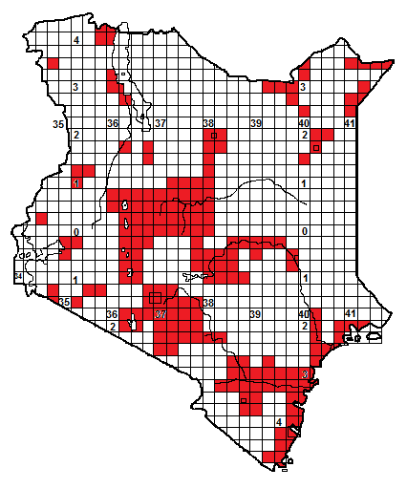 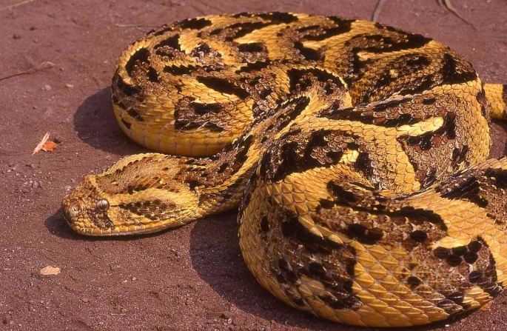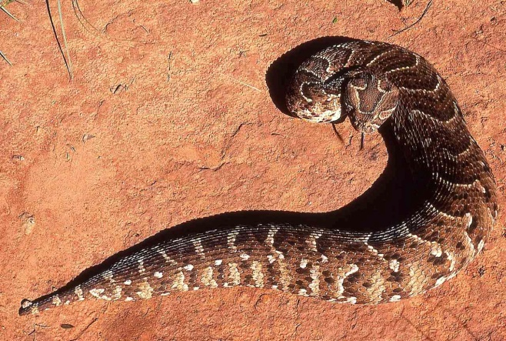

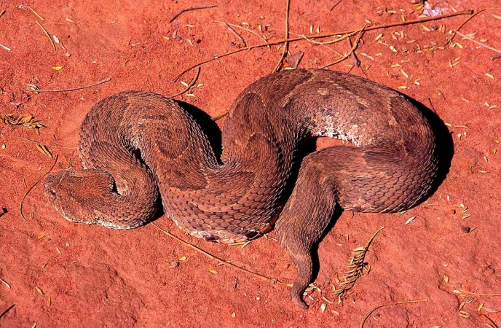 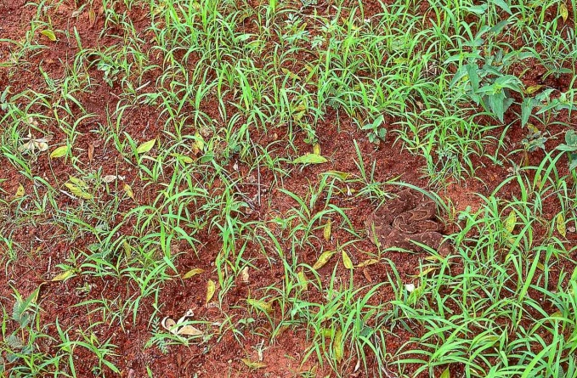

Illustrations; all adults; Nairobi (TL), captive (TR), Kajiado (BL), Botswana (BR)

**Local Names:** Moma, Kifutu, Bafe (Swahili), Abesa (Somali), Buti (Boran), Gitahuha (Kikuyu), Kimbuva (Kamba), Thuond Fu, Fu (Luo), Kipchuseit, Munywet (Kalenjin), Akipoon (Turkana), Nakwo (Luhya), Nturububwa (Maasai, Samburu), Mpua (Tharaka).

**Identification**: A big, fat, broad-headed heavy-bodied viper, with a pale line between the eyes. May reach 1.7 m in low-altitude areas, smaller in the highlands, average 70 cm to 1.1. m. Colour variable (grey, brown, yellowish) with a series of V-shapes, light and dark, along the back, pointing towards the tail. Lighter below, with dark markings on the outer edges of some scales.

**Distribution:** Occurs virtually throughout Kenya (although records lacking from some areas), in all types of savanna and semi-desert, absent only from high-altitude forest, moorland and closed forest, although unlikely to persist in very urbanised areas. Known from within or in the vicinity of almost very town in Kenya, including Nairobi, Mombasa, Eldoret, Nakuru, Malindi, Kisumu etc.

**Natural History**: Usually terrestrial. Active by night, but sometimes basks. Shelters under ground cover, below thick bushes, in leaf litter or in holes during the day. Eats mammals (fond of hedgehogs!), sometimes birds and amphibians; one ate a small tortoise. Gives live birth, usually 10-40, but one female had 156 babies.

**Conservation Significance**: Does not co-exist well with humans due to its size, but its camouflage means it often persists in agricultural areas. Found in most of Kenya’s conservation areas save the mountain parks; known from Nairobi National Park, Tsavo Mara, Samburu, Amboseli, Meru, Shimba Hills and the conservation areas on the Uaso Nyiro River.

**Medical Significance**: Kenya’s most dangerous snake, for several reasons; its large size, wide distribution in all types of savanna, its good camouflage, tendency to remain motionless when approached, rapid strike, long fangs and toxic venom. Bites characterised by strong pain, swelling, tissue destruction and blood blisters. Victims may recover but permanent tissue damage often results. Treat bites as medical emergencies and transport to hospital. Never tie anything above the bite site.

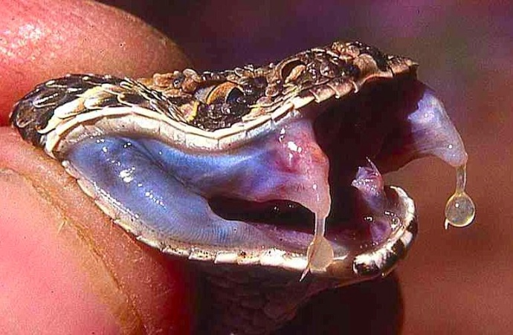 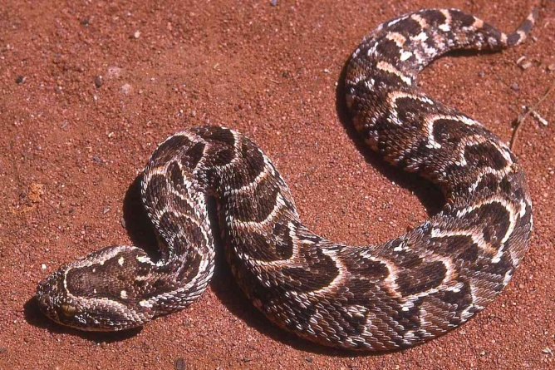

Juvenile Biis arietans somalica; Ogaden, Ethiopia

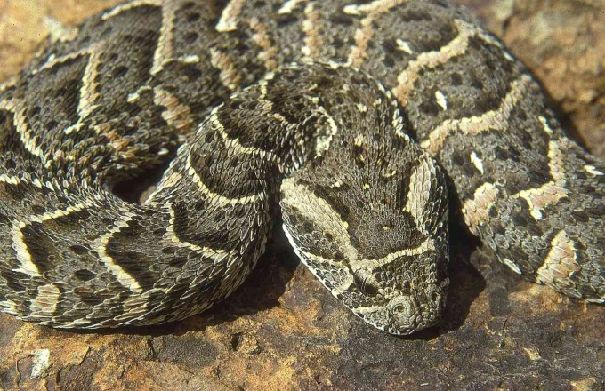

Adult; Watamu (below).

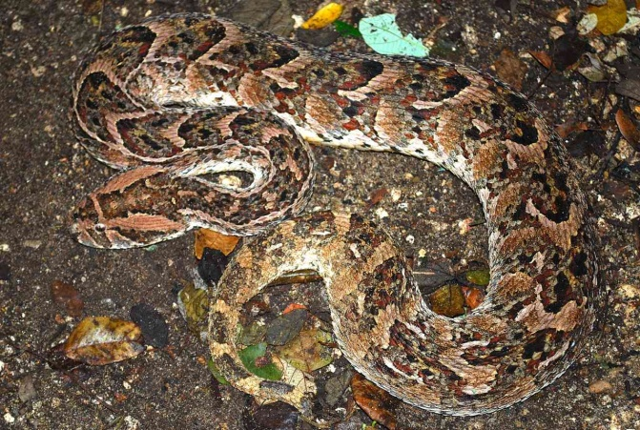

**Rhinoceros Viper Moma ya msitu *Bitis nasicornis***

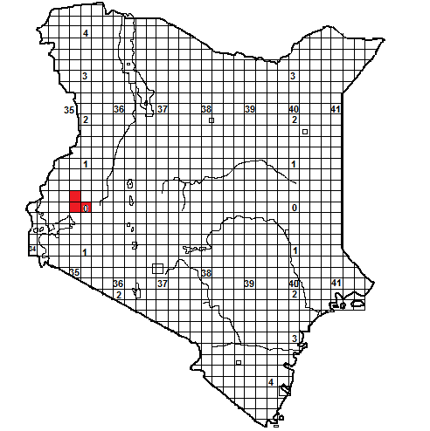

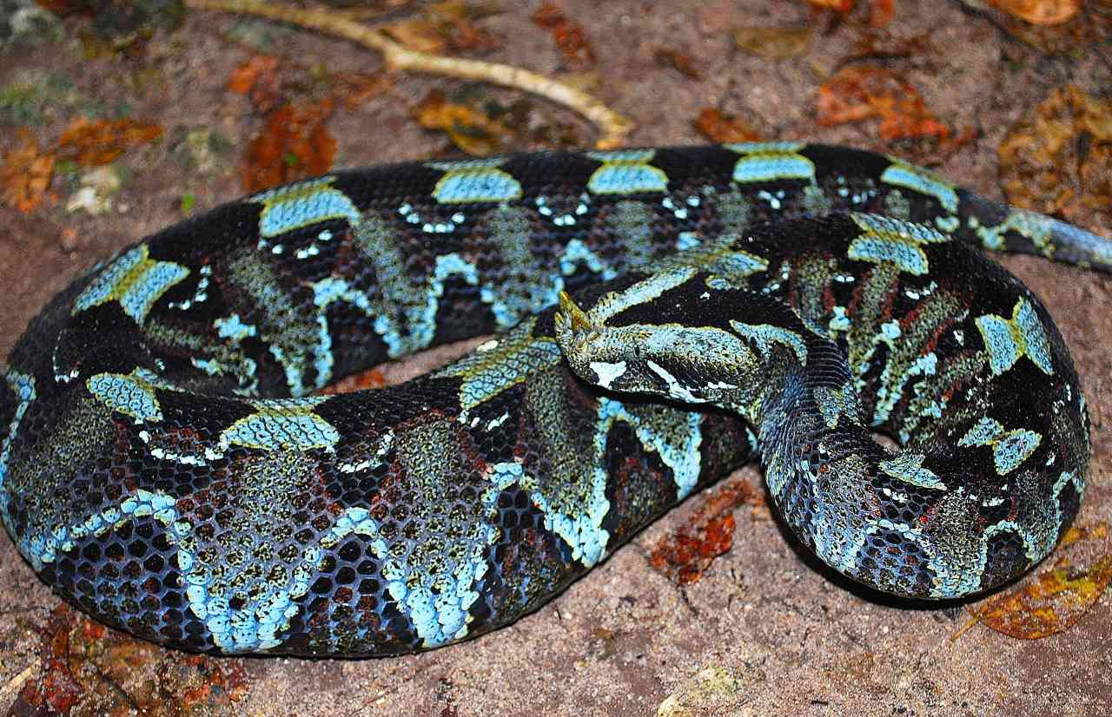 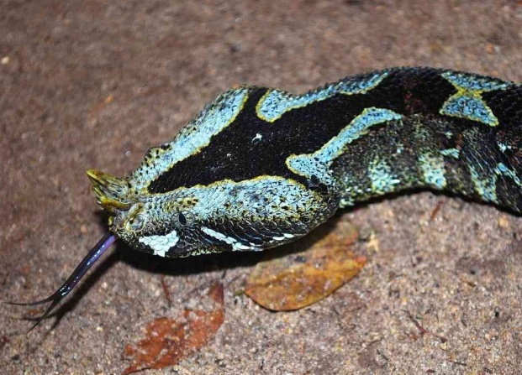

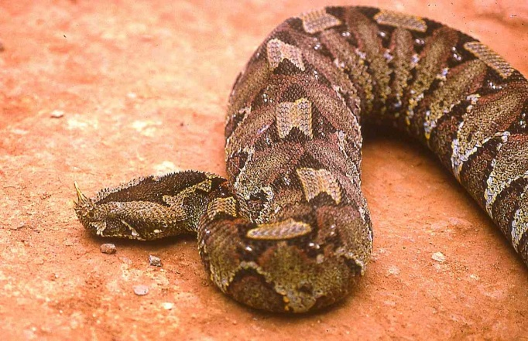 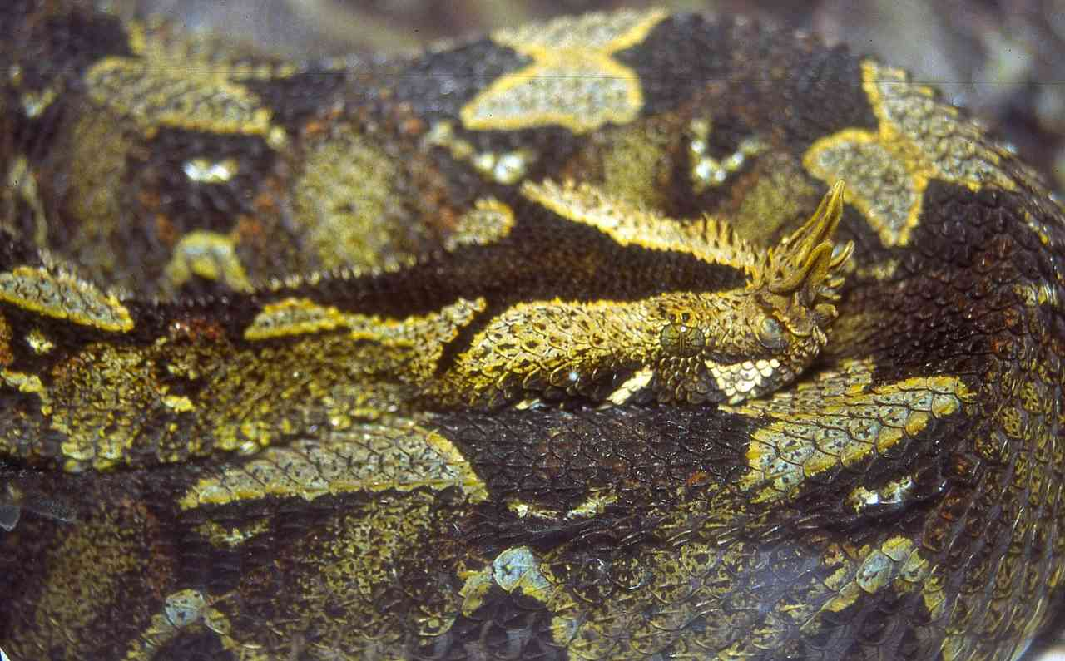

Illustrations; all adults, Kakamega (above) juvenile (below)

**Local Names:** None known.

**Identification**: A big, fat, heavy-bodied viper, with a flat triangular head and a cluster of horns on the nose, the front pair may be quite long. Average size 60-90 cm but may reach 1.2 m. Colour pattern complex; a chain of butterfly markings along the spine and a series of dark triangles on the flanks. Underside dirty white to dull green, blotched black or grey. A black arrow-head on top of the head. The neck and anterior body scales are very sharply keeled, possibly for defence.

**Distribution:** Woodland and forest of western Kenya, at medium to fairly high attitude. A forest snake; rarely found outside forest. Known from the Kakamega Forest, Nandi Hills, North and South Nandi Forests, Serem and the Yala River Valley.

**Natural History**: Usually terrestrial but it does climb into trees. Active by night. Hides among leaf litter, fallen trees, in holes and root tangles, will also climb into thickets, leaf clumps and tree cracks. Occasionally observed basking on roadsides in forests and forest glades, in the Nandi Forest it has been observed basking on small shrubs. Hunts from ambush. Has a tremendously loud hiss when angry. Eats small mammals, sometimes amphibians. Gives live birth, 6 to 38 babies.

**Conservation Significance**: Widespread in the great forests of central Africa. In Kenya, only likely to persist in the large western forests, but these have some protection, especially Kakamega and Nandi Forests.

**Medical Significance**: Has a toxic venom but few known bite cases. Probably similar to puff adder bite. Treat bites as medical emergencies; transport to hospital.

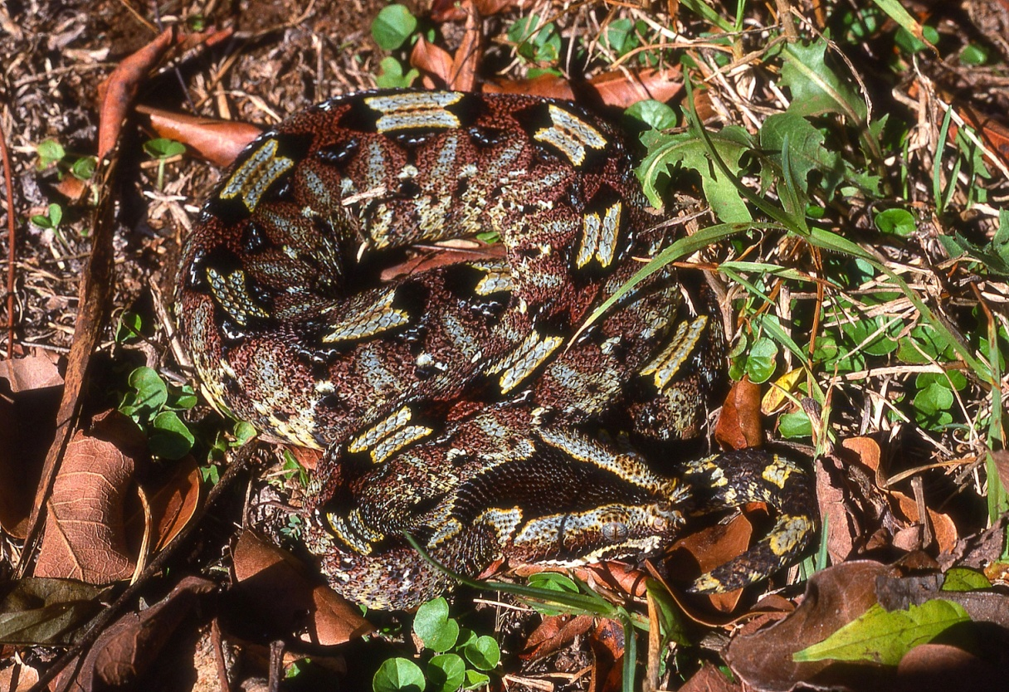

**Gaboon Viper Moma ya Gabon *Bitis gabonica*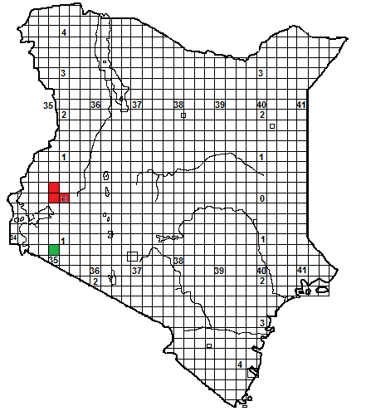** 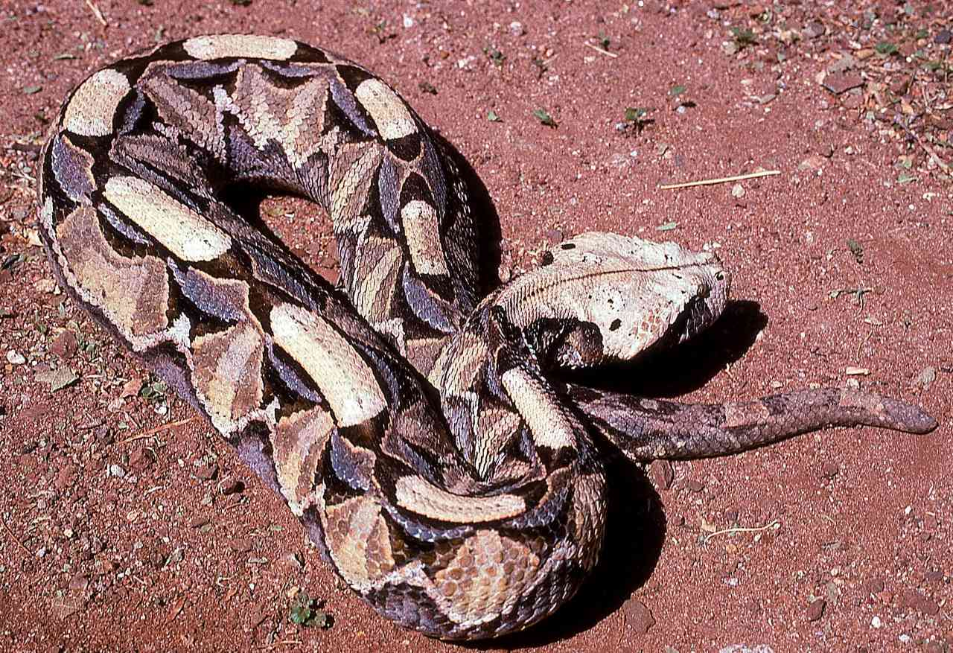

Illustrations; adults, above Kakamega Forest, below Zimbabwe.

**Local Names:** None known.

**Identification**: A big, fat, heavy-bodied viper, with a flat white triangular head, a tiny pair of horns is present between the raised nostrils. Average size 80cm to 1.3 m, but may reach 1.75 m or possibly larger. Colour pattern complex; a chain of pale rectangular markings along the spine and a series of purple triangles low on the flanks. Head white or cream, and a dark triangle below and behind each eye. Paler below, with irregular dark blotches.

**Distribution:** A snake of woodland, forest and forest/savanna mosaic, Africa-wide, but in Kenya apparently confined to the forests of the west. Known from the Kakamega Forest and Nandi Hills, there is sight record from Lolgorien (shown in green on the map).Reported from the Shimba Hills but no specimen exists.

**Natural History**: A slow-moving, placid, nocturnal viper, although known to bask. . Spends much time hidden in leaf litter, thick vegetation or under bushes. Often hunts by ambush, striking with its huge fangs, but known to prowl into open areas.. Often at the edge of the forest or in glades. Gives live birth, usually 10-30 young, but litters of 60 recorded. Eats mammals and birds, known to take small antelope.

**Conservation Significance**: Widespread in the great forests of central Africa. In Kenya, only likely to persist in the large western forests, but these have some protection, especially Kakamega Forest.

**Medical Significance**: A placid snake, and often reluctant to bite, but has a highly toxic venom, causing intense pain, blood blisters, and necrosis. Treat bites as a major medical emergency and transport to hospital.

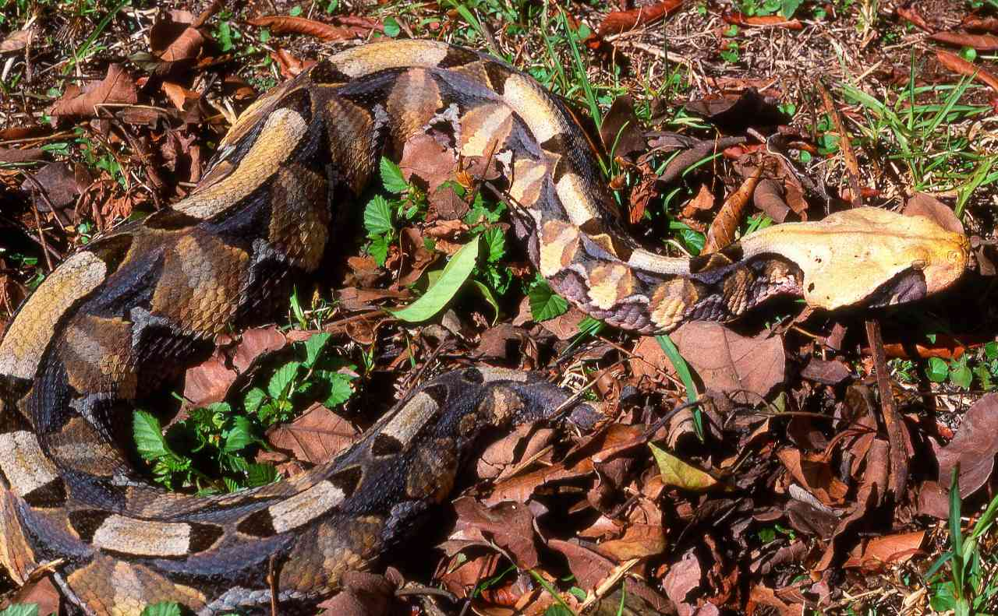

**Kenya Horned Viper Moma kidogo ya pembe *Bitis worthingtoni*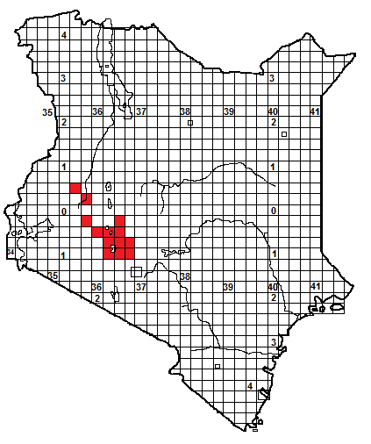**

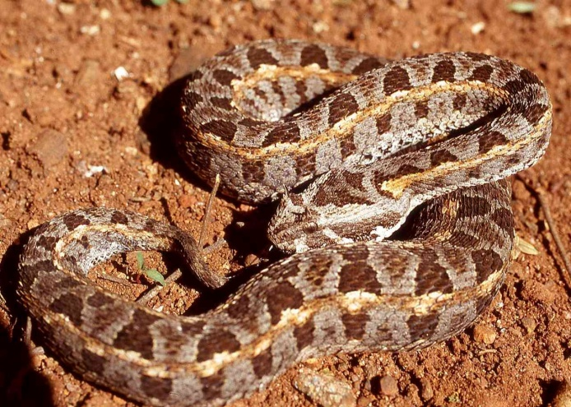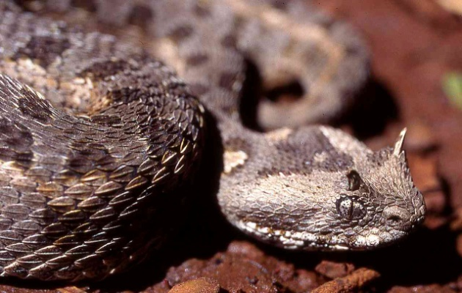

Illustrations: adults, below left Ndabibi, below right and end; Naivasha.

**Local Names:** Nturububwa en-kiti (Maasai)

**Identification**: A small stout viper with a distinctive horn above each eye, usually greyish in colour. Average size 20 to 35 cm, may reach 50 cm. Colour grey, along each flank a pale stripe, above and below this a series of sub-rectangular black markings. Head with a dark triangle. Belly pale, heavily stippled with grey.

**Distribution:** A Kenyan endemic, from the high grassland and savanna of the Gregory Rift Valley. It favours broken rocky country and scrub-covered hills along the escarpment, up to the forest’s edge, but is also on parts of the valley floor, in grassfields and acacia woodland. Occurs from the northern Kedong and Kijabe north along the Rift Valley, through Naivasha and Elmenteita to Nakuru and Njoro, thence up the western wall to Kipkabus and Eldoret. Also on the Kinangop and Ndabibi. Might be more widespread, for example on Mt Suswa and the escarpment east of Narok. Found in the vicinity of the following towns: Kijabe, Naivasha, Gilgil, Nakuru, Njoro, Eldoret, Ol Kalou.

**Natural History**: Poorly known. Terrestrial, slow moving but strikes quickly. Mostly nocturnal. Shelters under ground cover and in leaf litter. Eats mostly rodents and lizards. Gives live birth, 7 to 12 young.

**Conservation Significance**: Collected for the pet trade, especially around Naivasha, and many have been smuggled out of Kenya, including by dealers in Tanzania and Zambia claiming that their specimens were collected there. Its habitat is also under threat, as the central rift is prime farming country; it can tolerate stock farms but not smallholdings. Protected in Mt Longonot, Hells Gate and Lake Nakuru National Park, and conservancies around Lake Elmenteita, but the population needs surveying.

**Medical Significance**: Unlikely to be a medical hazard due to its small size. One bite involved mild swelling and local pain. 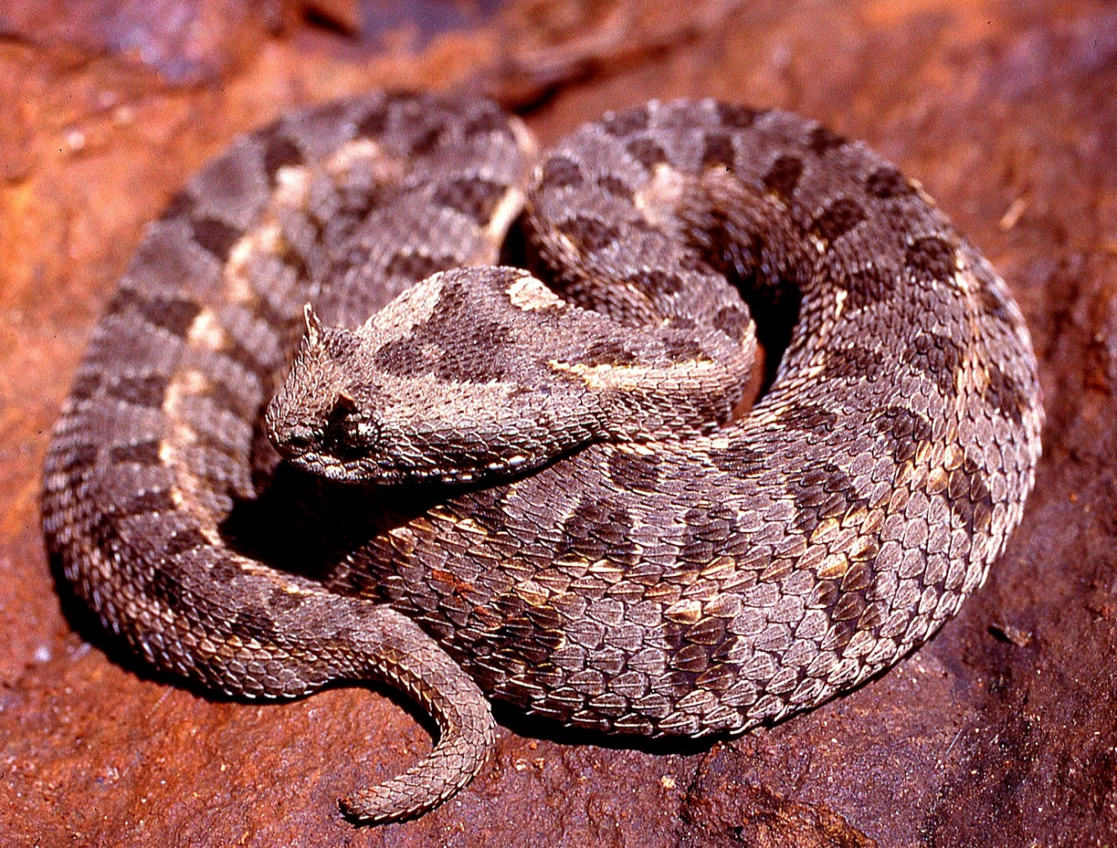

**Kenya Montane Viper *Montatheris hindii***

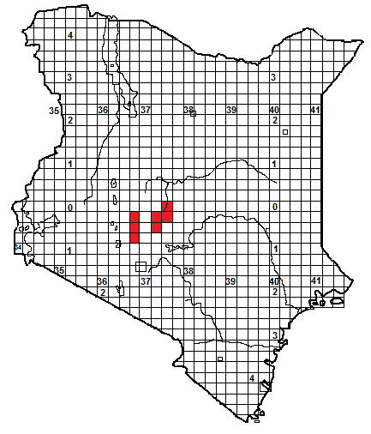

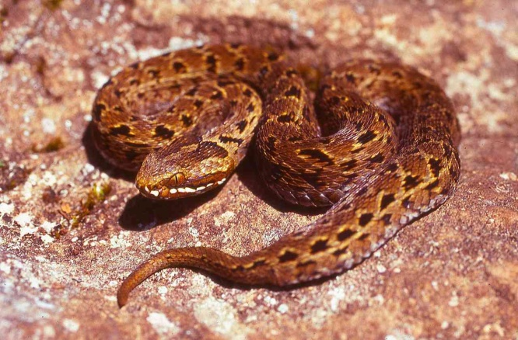 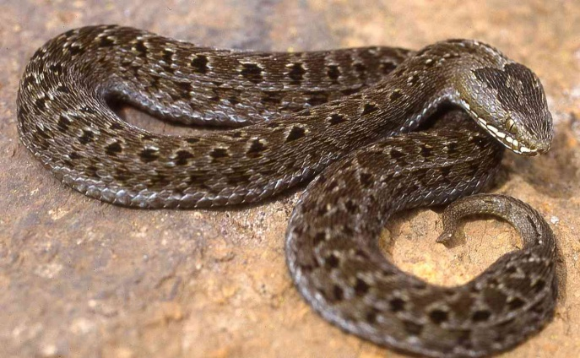

Illustrations, male (TL), female (TR), all specimens from Aberdares.

**Local Names:** None known

**Identification**: A small fairly slender viper, known only from the moorlands of the Aberdares and Mt Kenya. Average size 20 to 30 cm, may reach 35 cm. Grey or brown, there is sometimes a pale stripe along each flank, above and below this is a series of semi-circular, light edged markings. There is an irregular, arrow-like shape on the top of the head, often with a pale centre. Belly grey-white, speckled with grey.

**Distribution:** A Kenyan endemic. Lives in montane moorland, between 2 700 and 3 800 m altitude. Usually away from wooded areas, but may be found in giant heather thickets.

**Natural History**: Poorly known. Terrestrial, and sluggish unless warm. It emerges on sunny days to bask and may then hunt; takes cover if it clouds over. It shelters under ground cover and in thick grass and sedge tufts Eats lizards, frogs and small mammals. Gives live birth, two to three young. Gravid females need to bask more often than males and are thus found more often. Eaten by predatory birds, Augur buzzards have been seen eating them.

**Conservation Significance**: The whole population occurs entirely within two national parks, Mt Kenya and the Aberdares, and thus in theory the only threat to this species is climate change, as increasing temperatures might render its habitat too warm. An occasional specimen appears in the pet trade in the west, but the remoteness of most of this snake’s range means that it is secure.

**Medical Significance**: No known bites. Its small size means it is unlikely to be dangerous, although hikers in the high country might be at risk.

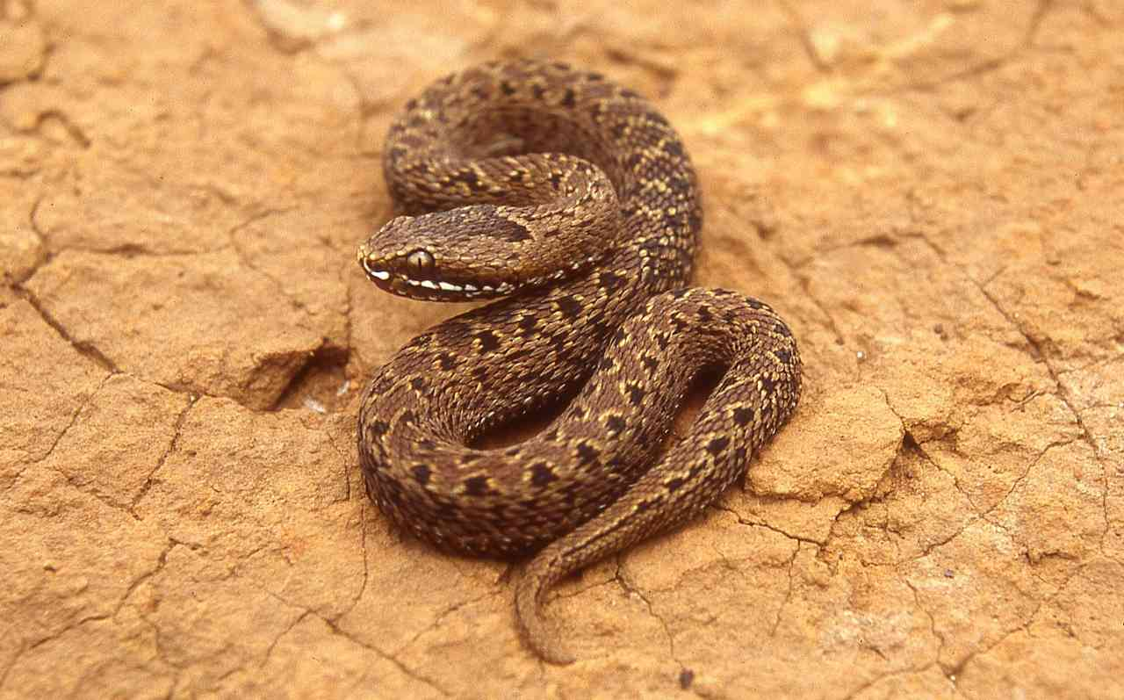

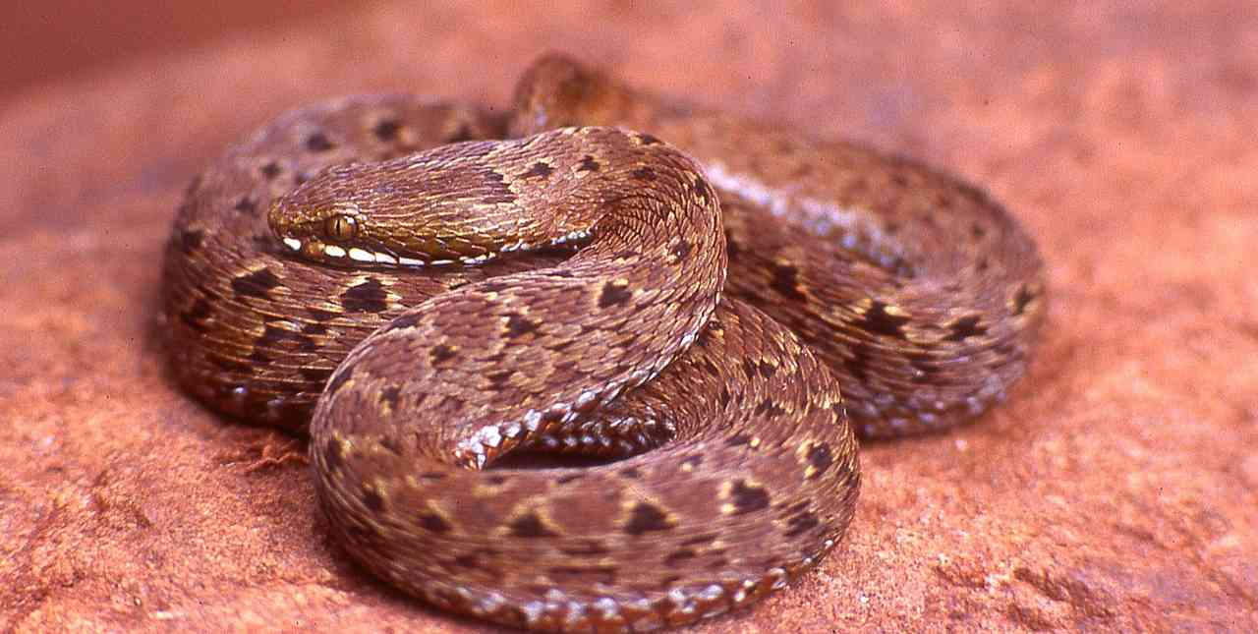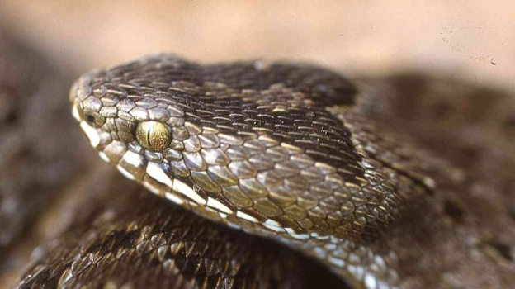

**North-east African Carpet Viper/ Saw-scaled Viper *Echis pyramidum***

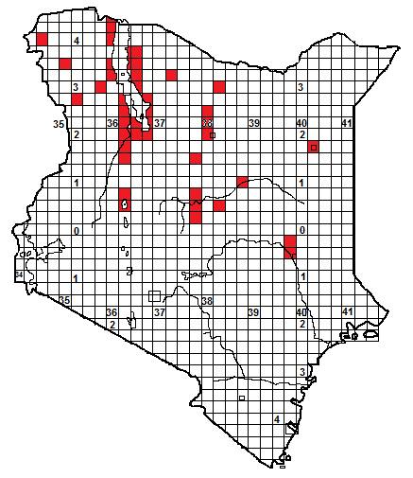

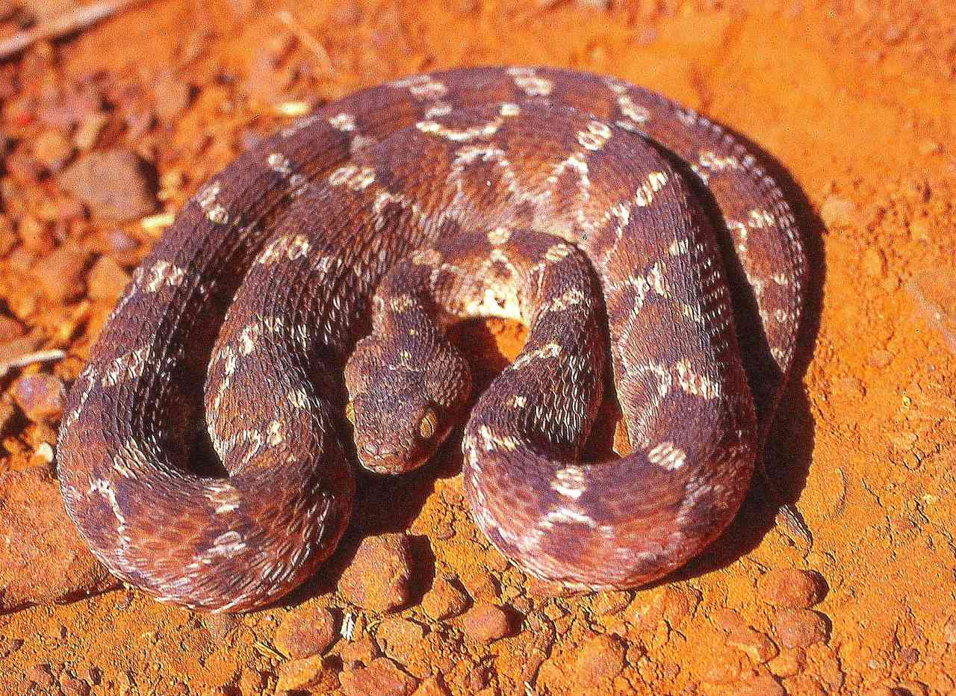 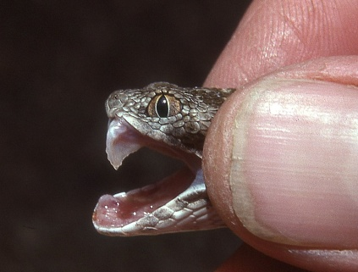

Illustrations: Baringo above, Wajir (below),

**Local Names:** Abesa (Somali), Buti jibbaa (Boran), Nturububwa (Samburu).

**Identification**: A small, fairly stout snake with a pear-shaped head and thin neck. Maximum size about 70 cm, average 30-50 cm. Ground colour variable (rufous, grey, brown, yellowish). There is a series of light ovoid cross bars along the back, along the flanks is a series of light-edged triangles or sub-triangles. The underside is white or cream with many tiny rufous spots.

**Distribution:** Sporadically distributed across dry northern Kenya, in dry savanna, semi-desert and near desert. Known from Lake Turkana and west of there; from Lake Baringo, and the lower Kerio River, in the low country around Mt Marsabit and Laisamis, Samburu National Reserve and the Uaso Nyiro River east of there. Also known from Wajir. Southernmost records from Garissa area (and recently found there just south of the Tan River). Might be much more widespread but unrecorded; much of northern Kenya is undercollected.

**Natural History**: Terrestrial and nocturnal; by day hides in holes, under rocks and other ground cover, may partially bury itself in sand or coil up in grass tufts. A spirited snake, when threatened it forms a series of C-shaped coils which are shifted against each other, the friction produces a sizzling sound; at the same time the snake may move back or forward and strike vigorously. It can also sidewind. Eats a variety of prey, fond of invertebrates such as scorpion and centipedes but will also eat other snakes, mammals and lizards. Lays from 4 to 20 eggs. Often abundant in parts of its range; at Moille Hill near Laisamis 7000 of these snakes were collected in just under 4 months. These snake very closely resemble egg-eating snakes, even experts have confused the two.

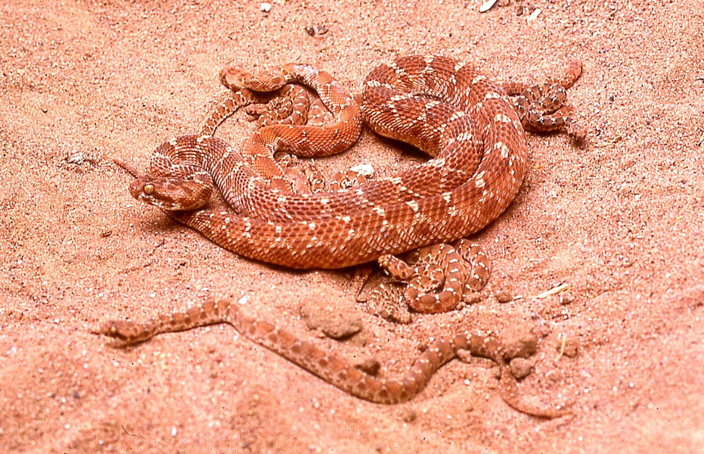

**Conservation Significance**: Occurs in several national parks (Samburu, Shaba, Losai, Marsabit, Sibiloi) and its abundance, small size and nocturnal habits means it will never be under any threat.

**Medical Significance**: Causes a lot of bites in northern Kenya, and the venom is an anticoagulant, as well as causing pain, swelling and necrosis. The venom is not as toxic as that of West African carpet vipers. However, bites should be treated as medical emergencies and transported to hospital. 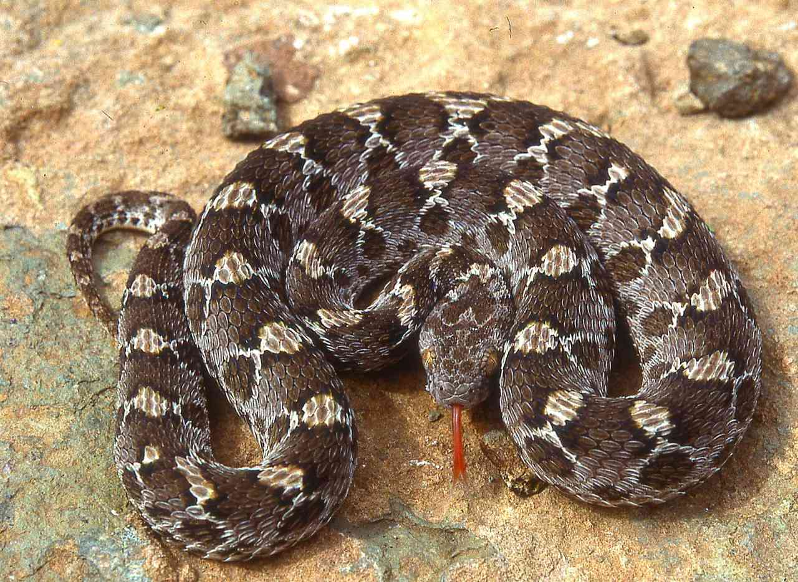 Ethiopia (left)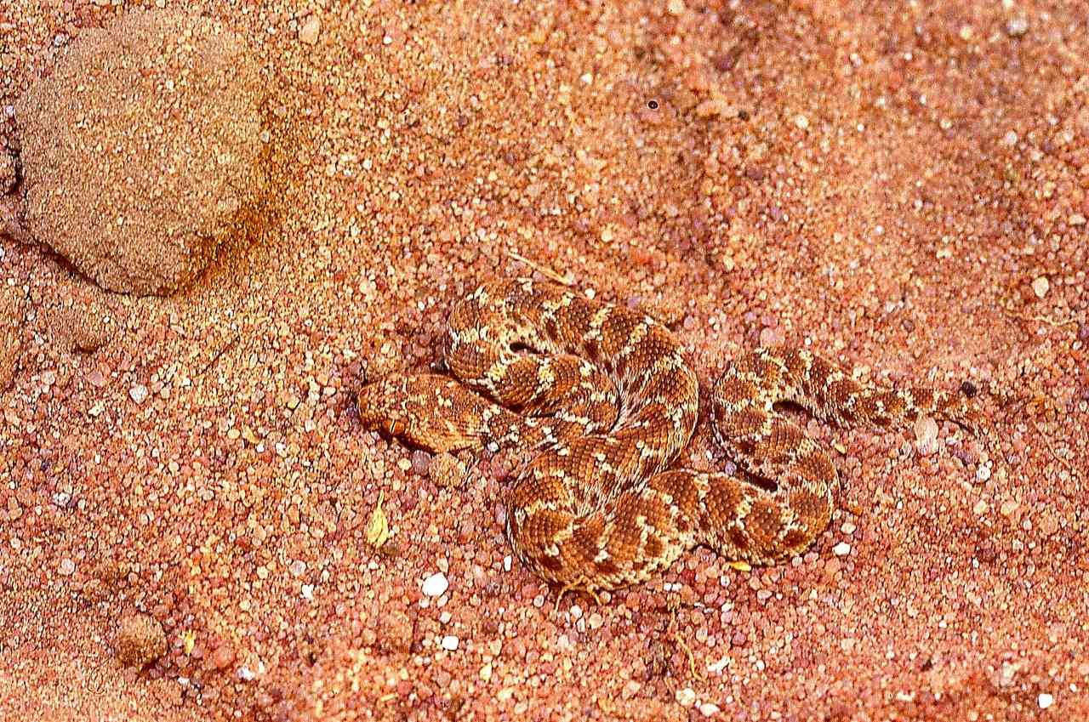Wajir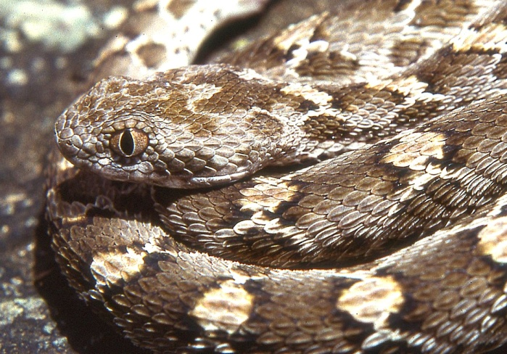Ethiopia